Units and Units Conversion
©2010 Richard P. Rumelt. This work is licensed under a Creative Commons Attribution NonCommercial 4.0 International License (CC BY-NC 4.0). You may copy, distribute, and adapt this material for non-commercial purposes, provided appropriate credit is given. Commercial use requires written permission from the author.

Working accurately with numbers often involves paying careful attention to the units of measurement.
All measures of real quantities are expressed in some kind of units. For example, accounting figures are normally expressed in dollars, or millions of dollars, or pounds sterling, etc. Output can be measured as units/day or perhaps as lbs./person-day. Paying attention to units will guide your through some thorny territory.
Consider, for example, the last measure of productivity given above and give it a value: 100 lbs./person-day. Note that 100 lbs./person per day is the same as 100 lbs/person/day, which is the same as 100 lbs./person-day. You should always try to express units as a simple fraction of things in the numerator to things in the denominator.
Suppose further that there are teams of 4 people and an output goal of 5 tons to be obtained in 5 weeks. How many teams are needed? This kind of problem can still quickly confuse lots of people. They approach it like an algebra problem when it isn’t. It is simply a problem in units conversion. This kind of problem is solved by multiplying and dividing by a series of numbers. To see what to do, write down what we know, showing the units:
- 5 tons, the output goal
- 4 persons/team, the team size
- 5 weeks, the time length
- 100 lbs./person-day, the productivity.
Now add to the list the units conversion ratios that seem appropriate. The two that seem needed here are
- 5 days/week, a working week
- 2000 lbs./ton, definition of a ton.
Start with something that has the units of the answer in the numerator. (If there is more than one item with the units of the answer in it, start with a ratio that increases the answer when it increases.) Start with (b), but turn it upside down:
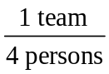
Now our job is to convert this into just teams by multiplying by conversion factors. We need something with persons in the numerator to cancel out the persons we already have in the denominator. Use the only option: multiply by the inverse of the productivity (d):
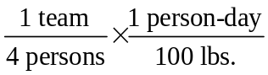
This gives us something that says there is 1 team-day per 400 lbs. of output. We have “cancelled” out persons. Moving right along, we want to cancel out lbs. if we can. So multiply by (f) to get
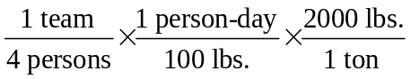.
Now divide by (e) to get rid of the day unit left in the numerator.
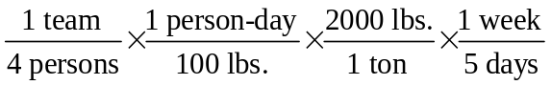
This leaves us with a productivity ratio measuring team-weeks/ton. We now have only to multiply by (a) and divide by (c) to reduce the thing to just teams. Alternatively, you could think of multiplying by the required output of 5 tons/5 weeks. This finally gives


In this example it was the units, not the numbers, telling us what to do. If you are having problems getting this approach to work, break the problem into smaller chunks. Sometimes the same measure appears in both the numerator and denominator, with different units (i.e., weeks in the numerator, months in the denominator). In such cases you have to pay attention to the logic of the conversion factors: ask yourself whether the factor you are about to use should multiply or divide the answer so far.

A Harder Problem
The marketing manager wants the sales force to visit each customer at least once per month. A customer visit takes, on average, 3 hours, so a salesperson can make, on average, 2 visits per day. Salespeople work 220 days each year. If there are 500 customers, how large a sales force is needed?
Here is what we know:
- 500 customers
- 12 visits/year
- 2 visits/day
- 220 days/year
Looking at this data there are several problems. The unit “salespeople” doesn’t appear and the unit “customers” appears only once, so there is nothing to cancel it out. Furthermore, there are lots of time interval units. The problem is that we have been sloppy. The units of (b) aren’t 12 visits per year, they are 12 visits/customer-year. And the units of (c) aren’t 2 visits/day, they are 2 visits/salesperson-day. To see the issue, note that 100 salespeople can generate 200 visits/day, whereas one salesperson can generate only 2 visits/day. So the parameter is not visits/day, it is visits per day per salesperson. Now lets try the list again:
- 500 customers
- 12 visits/customer-year
- 2 visits/salesperson-workday
- 220 salesperson-workdays/salesperson-years
Why have we defined (d) in this complex way rather than simply saying 220 days/year? Because there are 365.25 days in a year. So this ratio is not about days/year, it is about working days per year available per salesperson in a calendar year. To be even more careful we could have changed the “years” in (b) and (d) to calendar-years. But that is usually understood, so it is not normally necessary.
When the units get confusing, look to things like time and square-feet which are rough labels for sub-classes of unit. For example, a lumber plant may produce 30 square-feet of product per square-foot of plant per day. If you are not careful, the square-feet in the numerator just cancel the square-feet in the denominator. And the day is taken as a real 24 hour day. So be specific. The ratio is
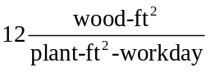.
Continuing with our sales example, we can start with a ratio that has salespersons in the numerator, or start with any variable that will go up and down with salespeople. Lets start with 500 customers. Then multiply by (b) to cancel the customers.
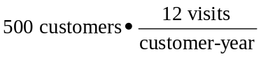
Now we have 6000 visits/year. That is the total number of visits the system has to generate. Note that we didn’t have to think much about whether to multiply or divide by 12⎯the units told us to multiply.
Next, multiply by the inverses of (c) and (d), guided by which units have to be cancelled out:
The only units left after all this canceling are “salespersons,” which is what we wanted to know. So the answer is 500x12/(2x220) = 13.6 salespeople.
If you are facile with numbers, you probably would have done this much more directly. You would have first computed that you need 500x12 = 6000 visits per year. Then you would have computed that one salesperson makes 220x2 = 440 visits in a year. So you need 6000/440 sales people. But what does it mean to be facile with numbers? In cases like this, it means you have a good intuition about how to break the problem into parts so that the units aren’t too confusing when you want to put it back together. One way to develop this facility, if you don’t already have it, is to work carefully with the units as we have shown above. Then you will learn how these problems come apart and go back together again.

